DOVELET

SC0074 for the Detection of Ethanol Vapors in Airs

PRODUCT INFORMATION

Features: Application:
- No heater and low power consumption ※ the breath alcohol detector
- Wide detection range
- High sensitivity
- Fast response
- Long life and low cost
- Uses simple electrical circuit
- Small size

The sensing element is comprised of SnO₂ multi-crystalloid appending propriety extender. It has tiny pearl structure, in the presence of ethanol vapors in airs. A simple electrical circuit can convert the change in conductivity to an output signal which corresponds to the alcohol concentration.
SC0074 has high sensitivity to low concentrations of ethanol vapors in air. It is be used in the breath alcohol detector. We also supply a microprocessor and special software for handing the sensor’s signal for application.
The figure below represents typical sensitivity characteristics, all data having been gathered at standard test conditions,. Y-axis is indicated as sensor’s out Vo.

Sensitivity Characteristics:

The figure below represents typical temperature and humidity dependency characteristics. Again, the Y-axis is indicated as sensor’s out Vo.

Temperature/Humidity Dependency:

95％RH
96h T=40℃ H=93％RH
V V
4v

3v
2v
2v
1v
1v

0℃ 20℃ 40℃ 60℃ temperature 0 30 60 90 120 hour

Important Note: Operation conditions in which SC0074 are used will vary with each customer’s specific applications, we strongly recommends consulting our technical staff before deploying TP-3 in your application and in particular, when customer’s target gases are not listed herein. We can’t assume any responsibility for any use of its sensors in a product or application for which sensor has not been specifically tested by us.

Basic Measuring Circuit:

Sensor

V_{I} Vo
R_{L}
The sensor requires only one voltage inputs V_{I}.
The RL is a load resistor which is connected in
series with the sensor. DC voltage is required
for the circuit voltage since the sensor has
polarity. Vo is applied to allow measurement
of voltage across a load resistor (R_{L}).
Specifications:
Model Number | SC0074
Target Gases | C₂H₅OH(ethanol)
Typical Detection Range | 30~500ppm ethanol vapors
Standard Circuit Conditions | Circuit Voltage | V_{I} | 7.5V DC
Standard Circuit Conditions | Load Resistance | R_{L} | 51Ω
Electrical Characteristics under Standard Test Condition | Power Consumption | Ps | ≤150mW
Electrical Characteristics under Standard Test Condition | Circuit Current | I_{S} | ≤15mA
Standard Test Conditions | Test Gas Condition | Normal air at 20±2℃  65±5%RH
Standard Test Conditions | Circuit Conditions | 6~8 V DC
Standard Test Conditions | Conditioning period before test | ≤20 s

The value of power consumption (Ps) can be calculated by utilizing the following formula: Ps=Vo/R_{L}·V_{I}.

Structure and Dimensions:
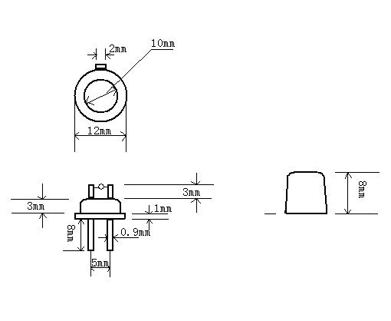

Notes:
- Do not use it reversedly. The mark in the cap indicates the negative pole.

欢迎来电洽购我司产品或索取免费详细资料、设计选型指南和光盘 、样品；产品繁多未能尽录，欢迎来电查询。
中国传感器科技信息网：HTTP：//WWW.SENSOR-IC.COM/
工控安防网：HTTP：//WWW.PC-PS.NET/
消费电子专用电路网：HTTP://WWW.SUNSTARE.COM/
E-MAIL： xjr5@163.com szss20@163.com
MSN: suns8888@hotmail.com
QQ:195847376
地址： 深圳市福田区福华路福庆街鸿图大厦1602室
电话：0755-83778810 83394033 83376282 83387030 83387016
传真：0755-83376182 83338339 邮编：518033 手机：(0)13902971329
深圳展销部：深圳华强北路赛格电子市场2583号 TEL/FAX：0755-83665529 13823648918
北京分公司：北京海淀区知春路132号中发电子大厦3097号
TEL：010-81159046 82615020 13823791822 FAX：010-62543996
上海分公司：上海市北京东路668号上海賽格电子市场地下一层D25号
TEL：021-28311762 56703037 13823676822 FAX：021-56703037
西安分公司：西安高新开发区20所(中国电子科技集团导航技术研究所)
西安劳动南路88号电子商城二楼D23号
TEL：029-81022619 13072977981 FAX:029-88789382
成都：TEL:(0)13717066236
技术支持：0755-83394033 13501568376

