BF350-2GB-CL15 高精度应变片
图样 | 产品型号 | 敏感栅尺寸（长X宽) |  | 基底尺寸（长X宽）
图样 | 产品型号 | mm | INCHES | mm | INCHES
 | BF350-2GB-CL15(**)-X | 2.0X4.6 | 0.079X0.181 | 10.3X5.5 | 0.406X0.217
 | BF350-3GB-AL15(**)-X | 3.0X2.7 | 0.118X0.106 | 20.0X4.1 | 0.787X0.161
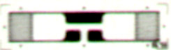 | BF(BA)350-1GB(**)N* | 1.5X2.5 | 0.059X0.098 | 13.8X3.8 | 0.543X0.150
 | ZF350-1GB-AL-M**N* | 1.5x3.0 | 0.059X0.118 | (L1+3)X4.2 | (L1+0.118)X0.165
 | BF(BA)350-2GB-A(**) | 2.0X3.0 | 0.079X0.110 | 10.8X4.4 | 0.425X0.173
 | BF(BA)750-3GB-AL*(**)-N* | 3.0X3.5 | 0.118X0.138 | (L1+4.8)X4.3 | (L1+0.189)X0.169
 | ZF1000-1.6GB-AL0-M**T* | 1.6X3.9 | 0.063X0.154 | 14.0X5.2 | 0.551X0.205
 | ZF1000-2GB-AL6(**)T* | 2.0X2.8 | 0.079X0.110 | 9.4X3.8 | 0.370X0.150
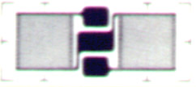 | BF500-3GB(**)N* | 3.0X4.1 | 0.118X0.161 | 12.0X5.4 | 0.472X0.213
 | BF500-4GB(**) | 3.4X4.1 | 0.134X0.161 | 13.0X5.4 | 0.512X0.213
 | ZF1000-2GB-BL6-M**-N* | 2.1X4.1 | 0.083X0.161 | 9.5X4.6 | 0.374X0.181
 | BF1000-3GB-BL7(**)-N* | 3.0X5.5 | 0.118X0.217 | 11.6X6.5 | 0.457X0.265
 | ZF1000-2GB-BL7-M23-N6 | 2.1X4.1 | 0.083X0.161 | 9.7X5.5 | 0.382X0.217
 | ZF2000-2GB-BL6-N* | 2.1X4.1 | 0.083X0.161 | 9.7X5.5 | 0.382X0.217
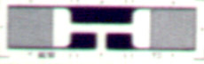 | ZF350-2GB-AL*-M**-N* | 2.0X2.6 | 0.079X0.102 | (L1+3.8)X3.6 | (L1+0.15)X0.142
 | BF(BA)350-3GB-AL*(**)-N*  ZF1000-3GB-AL*-M**-N* | 3.0X2.9 | 0.118X0.113 | (L1+4.8)X4.3 | (L1+0.189)X0.169
 | ZF750-2GB-AL2-M**-N* | 2.0X3.3 | 0.079X0.130 | 15.8X4.5 | 0.622X0.177
 | ZF1000-2GB-AL0-M**-N* | 2.1X3.3 | 0.083X0.130 | 14.3X4.5 | 0.563X0.177
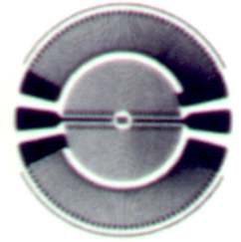 | BF350-(10)KA(**)  ZF1000-(10)KA(**) | Ø9.0 | 0.354 | 10.0 | 0.394
 | BF350-(15)KA(**) | 14.0 | 0.551 | 15.0 | 0.591
 | BF350-(20)KA(**)  ZF1000-(20)KA(**) | 19.0 | 0.748 | 20.0 | 0.787
 | ZF350-(20)KA(**) | 19.0 | 0.748 | 20.0 | 0.787
 | ZF420-(7)KA(**) | 6.3 | 0.248 | 9.9 | 0.390
 | ZF420-(7)KA | 7.0 | 0.276 | 9.9 | 0.390
 | ZF1000-(13)KA(**) | 12.0 | 0.472 | 13.0 | 0.512
 | ZF1000-(14)KA(**) | 13.0 | 0.512 | 14.0 | 0.551
 | ZF1000-(15)KA(**) | 14.0 | 0.551 | 15.0 | 0.591
 | ZF1000-(14)KA(**)-D | 12.8 | 0.504 | 14.0 | 0.551
 | ZF1000-(13)KA(11)-D | 9.8 | 0.386 | 13.0 | 0.512
 | ZF2000-14KA(11)-D | 13.6 | 0.535 | 14.0 | 0.551
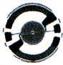 | BF350-(8.5)KA-B(16)-X | 8.5 | 0.335 | 9.0 | 0.354
 | ZF1000-(10)KA-B | 9.0 | 0.354 | 10.0 | 0.394
 | ZF2000-(12)KA-B | 11.8 | 0.465 | 12.0 | 0.472
 | BF350-(20)KA-C(**) | 19.0 | 0.748 | 20.0 | 0.787
 | ZF1000-(20)KA-C(**) | 19.0 | 0.748 | 20.0 | 0.787
 | ZF350-(20)KA-C(**) | 19.0 | 0.748 | 20.0 | 0.787
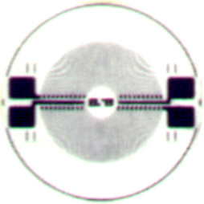 | ZF1000-(11)KB(**)-D | 6.7 | 0.264 | 10.9 | 0.429
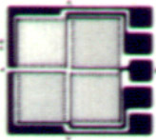 | ZF350-2EB-A-M(**) | 1.8X2.2 | 0.071X0.087 | 8.4X7.3 | 0.331X0.287
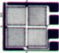 | ZF300-2EB(**) | 1.8X2.2 | 0.071X0.087 | 8.5X7.3 | 0.335X0.287
 | BF350-2EB(**)  ZF1000-2EB(**) | 2.3X2.7 | 0.091X0.106 | 8.6X7.1 | 0.339X0.280
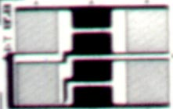 | BF350-1FG-BL0(**)-T* | 1.5X2.8 | 0.059X0.110 | 13.5X6.9 | 0.531X0.272
 | ZF350-1FG-BL*-M*-N* | 1.5X2.3 | 0.059X0.091 | (L1+3.8)X6.2 | (L1+0.150)X0.244
 | ZF1000-1.5FG-BL0-M**-T* | 1.5X2.8 | 0.059X0.110 | 14.1X6.9 | 0.555X0.272
 | ZF1000-2FG-BL*-M**-N* | 2.1X2.8 | 0.083X0.110 | (L1+4.3)X6.9 | (L1+0.169)X0.272.
 | BF350-2FG-EL6(**)T* | 2.1X2.8 | 0.083X0.110 | (L1+4.3)X6.9 | (L1+0.169)X0.272
 | BF350-3FG-BL0(**)-T*  ZF1000-3FG-BL0-M**-T* | 3.1X2.8 | 0.122X0.110 | 15.3X6.8 | 0.602X0.267
 | ZF2000-3FG-BL0-M**-T* | 2.0X3.3 | 0.079X0.130 | 14.6X7.8 | 0.575X0.307
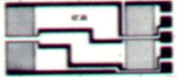 | BF350-3FG-AL*(**)-N*  ZF1000-3FG-AL*-M**-N* | 3.1X3.2 | 0.122X0.126 | (L1+6.1)X8.5 | (L1+0.240)X0.335
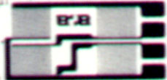 | ZF350-1FG-L0-M**-T* | 1.5X2.4 | 0.059X0.094 | 14.4X6.4 | 0.567X0.252
 | BF350-2FG-L0(**)-T* | 2.0X2.7 | 0.079X0.106 | 14.6X6.9 | 0.575X0.272
 | ZF350-2FG-L*-M**-T* | 2.0X2.5 | 0.079X0.098 | (L1+4.5)X6.4 | (L1+0.177)X0.252
 | ZF1000-3FG-L*-M**-N* | 3.0X2.5 | 0.118X0.098 | (L1+7.1)X6.6 | (L1+0.280)X0.260
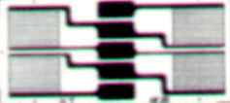 | BF350-3FG-CL0(**)-T* | 3.1X2.8 | 0.122X0.110 | 15.4X7.0 | 0.606X0.276
 | ZF350-1FG-CL*-M**-N* | 1.5X2.3 | 0.059X0.091 | (L1+3.1)X6.2 | (L1+0.122)X0.244
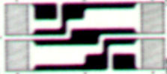 | BF350-1FG-DL0(**)-T* | 1.5X2.5 | 0.059X0.098 | 13.9X6.5 | 0.547X0.291

欢迎来电洽购我司产品或索取免费详细资料、设计选型指南和光盘 、样品；产品繁多未能尽录，欢迎来电查询。
中国传感器科技信息网：HTTP：//WWW.SENSOR-IC.COM/
工控安防网：HTTP：//WWW.PC-PS.NET/
消费电子专用电路网：HTTP://WWW.SUNSTARE.COM/
E-MAIL： xjr5@163.com szss20@163.com
MSN: suns8888@hotmail.com
QQ:195847376
地址： 深圳市福田区福华路福庆街鸿图大厦1602室
电话：0755-83778810 83394033 83376282 83387030 83387016
传真：0755-83376182 83338339 邮编：518033 手机：(0)13902971329
深圳展销部：深圳华强北路赛格电子市场2583号 TEL/FAX：0755-83665529 13823648918
北京分公司：北京海淀区知春路132号中发电子大厦3097号
TEL：010-81159046 82615020 13823791822 FAX：010-62543996
上海分公司：上海市北京东路668号上海賽格电子市场地下一层D25号
TEL：021-28311762 56703037 13823676822 FAX：021-56703037
西安分公司：西安高新开发区20所(中国电子科技集团导航技术研究所)
西安劳动南路88号电子商城二楼D23号
TEL：029-81022619 13072977981 FAX:029-88789382
成都：TEL:(0)13717066236
技术支持：0755-83394033 13501568376

